Q1-Q6

ACER@DESKTOP-JUB4C23 MINGW64 ~

$ git --version

git version 2.33.1.windows.1

ACER@DESKTOP-JUB4C23 MINGW64 ~

$ mkdir test

ACER@DESKTOP-JUB4C23 MINGW64 ~

$ cd test

ACER@DESKTOP-JUB4C23 MINGW64 ~/test

$ git init

Initialized empty Git repository in C:/Users/ACER/test/.git/

ACER@DESKTOP-JUB4C23 MINGW64 ~/test (master)

$ git status

On branch master

No commits yet

Untracked files:

(use "git add <file>..." to include in what will be committed)

index.html.txt

nothing added to commit but untracked files present (use "git add" to track)

ACER@DESKTOP-JUB4C23 MINGW64 ~/test (master)

$ git add idex.html.text

fatal: pathspec 'idex.html.text' did not match any files

ACER@DESKTOP-JUB4C23 MINGW64 ~/test (master)

$ git add index.html.text

fatal: pathspec 'index.html.text' did not match any files

ACER@DESKTOP-JUB4C23 MINGW64 ~/test (master)

$ git commit -m "comitting a text file"

Author identity unknown

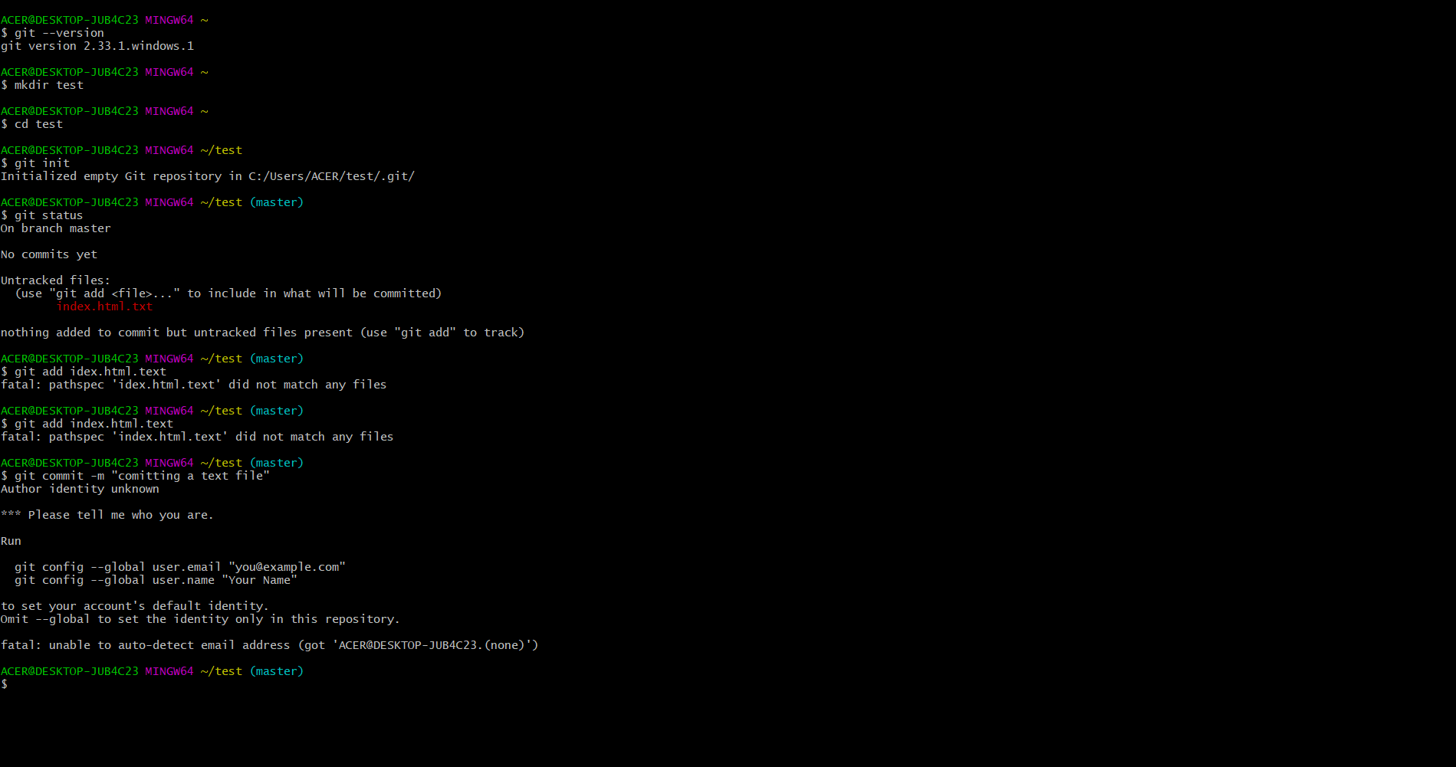

ACER@DESKTOP-JUB4C23 MINGW64 ~/test (master)

$ git config --global user.username nikkzjr10

ACER@DESKTOP-JUB4C23 MINGW64 ~/test (master)

$ git remote add origin https://github.com/nikkzjr10/index.html.git

ACER@DESKTOP-JUB4C23 MINGW64 ~/test (master)

$ git push origin master

error: src refspec master does not match any

error: failed to push some refs to 'https://github.com/nikkzjr10/index.html.git'

ACER@DESKTOP-JUB4C23 MINGW64 ~

$ git clone https://github.com/nikkzjr10/file-text.git

Cloning into 'file-text'...

remote: Enumerating objects: 6, done.

remote: Counting objects: 100% (6/6), done.

remote: Compressing objects: 100% (2/2), done.

remote: Total 6 (delta 0), reused 0 (delta 0), pack-reused 0

Receiving objects: 100% (6/6), done.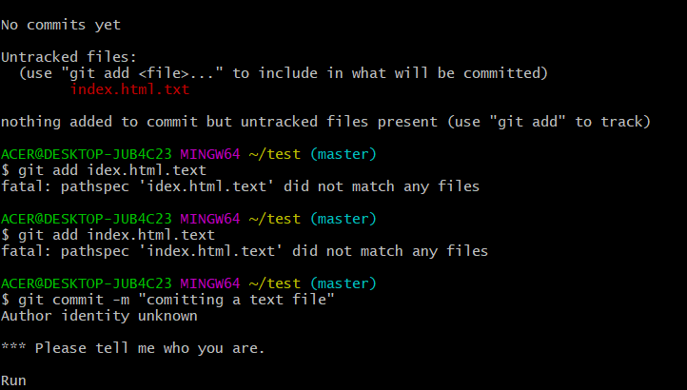

ACER@DESKTOP-JUB4C23 MINGW64 ~

$ ls

-1.14-windows.xml

'3D Objects'/

AppData/

'Application Data'@

Contacts/

Cookies@

Desktop/

Documents/

Downloads/

Favorites/

IntelGraphicsProfiles/

Links/

'Local Settings'@

Music/

'My Documents'@

NTUSER.DAT

NTUSER.DAT{c3a341e3-29aa-11ec-acbe-9e4dc6d1086e}.TM.blf

NTUSER.DAT{c3a341e3-29aa-11ec-acbe-9e4dc6d1086e}.TMContainer00000000000000000001.regtrans-ms

NTUSER.DAT{c3a341e3-29aa-11ec-acbe-9e4dc6d1086e}.TMContainer00000000000000000002.regtrans-ms

NetHood@

OneDrive/

Pictures/

PrintHood@

Recent@

'Saved Games'/

Searches/

SendTo@

'Start Menu'@

Templates@

Tracing/

Videos/

file-text/

mintty.2021-10-21_14-04-08.png

ntuser.dat.LOG1

ntuser.dat.LOG2

ntuser.ini

test/

ACER@DESKTOP-JUB4C23 MINGW64 ~

$ cd test

ACER@DESKTOP-JUB4C23 MINGW64 ~/test (master)

$ ls

index.html.txt

ACER@DESKTOP-JUB4C23 MINGW64 ~/test (master)

$ git status

On branch master

No commits yet

Untracked files:

(use "git add <file>..." to include in what will be committed)

index.html.txt

nothing added to commit but untracked files present (use "git add" to track)

ACER@DESKTOP-JUB4C23 MINGW64 ~/test (master)

$ git add index.html.txt

ACER@DESKTOP-JUB4C23 MINGW64 ~/test (master)

$ git status

On branch master

No commits yet

Changes to be committed:

(use "git rm --cached <file>..." to unstage)

new file: index.html.txt

ACER@DESKTOP-JUB4C23 MINGW64 ~/test (master)

$ git commit -m 'first version of index file'

Author identity unknown

*** Please tell me who you are.

Run

git config --global user.email "you@example.com"

git config --global user.name "Your Name"

to set your account's default identity.

Omit --global to set the identity only in this repository.

fatal: unable to auto-detect email address (got 'ACER@DESKTOP-JUB4C23.(none)')

ACER@DESKTOP-JUB4C23 MINGW64 ~/test (master)

$ git status

On branch master

No commits yet

Changes to be committed:

(use "git rm --cached <file>..." to unstage)

new file: index.html.txt

ACER@DESKTOP-JUB4C23 MINGW64 ~/test (master)

$ git log

fatal: your current branch 'master' does not have any commits yet

ACER@DESKTOP-JUB4C23 MINGW64 ~/test (master)

$

